**Guided Capstone Project Report: Big Mountain Resort Findings and Recommendations**

When Big Mountain first approached us, they were looking for a more sophisticated ticket pricing strategy that would take into consideration the value of their equipment and facilities and the relationship that those features have with their ticket price and revenue especially compared to competing resorts. Currently Big Mountain prices their tickets at a premium above the average ski resort ticket price of $63.81 but are looking for a model and beats the average model and also gives resort leadership some insight on where to invest their resources for future features and reign in spending and cutting costs to improve their overall bottom line.

First, its important to understand where Big Mountain sits in regards to price both in the state of Montana and the US:

**Fig. 1-2: Adult Weekend ticket price distribution for Montana and US:**

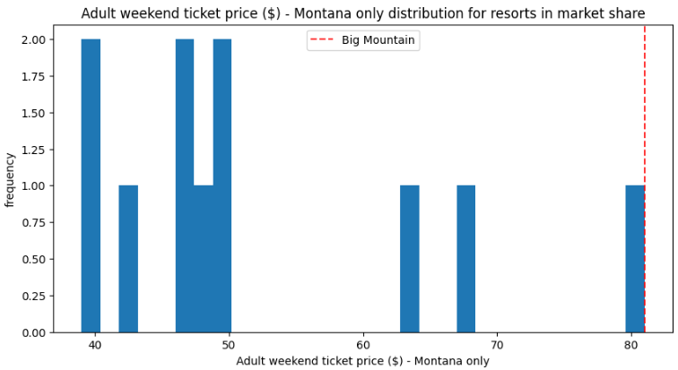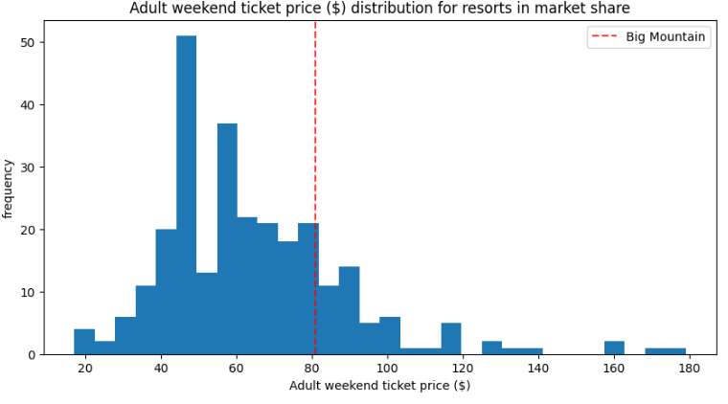

As can be seen from the figures above Big Mountain at $81.00 per Weekend Ticket is priced at the top of its state market and also relatively high compared to the US market so any changes in price will have to be carefully planned so as not to lose patrons.

That being said there are some strong indicators that some resort features have a more direct relationship to ticket price than others. Below in figure 3 is a heat map generated that shows the correlations between different resort features to each other and also to ticket price (AdultWeekend). Interestingly, the most highly correlated features to price are:

* Vertical Drop
* Snow Making
* Total Chairs
* Fast Quads
* Runs

**Fig. 3: Ski Resort Features Correlated in Dark (less correlated) to Light (more correlated):**

­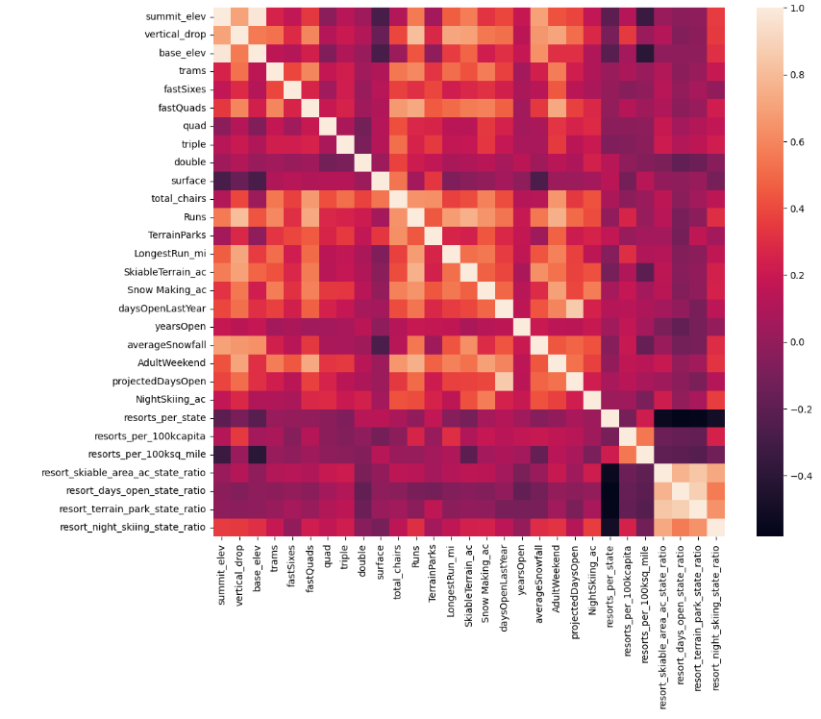

These findings were also supported by the random forest regressor that had these same features in common with the heat map. Given, that we now have discovered the leading indicators of the feature to price relationship and given that the random forest regressor model was selected as it had the least amount of variability we concluded that the modelled price for Big Mountain is $95.87 with a mean absolute error of $10.39. So, while the modelled price is much higher than the actual price it is still wise to err on the conservative side of the model as the entire MAE subtracted from the modelled price would only be $85.87 which is only a few dollars more than the current actual price.

After we narrowed our model and selected the features we wanted to observe we were then approached with a few scenarios from resort management:

1. Close down up to 10 of the least used runs.
2. Increase the vertical drop by 150 feet by expanding the lowest run and installing a lift.
3. Same as two but add additional snow making to cover the lower area.
4. Increase the longest run by 0.2 miles and increase snow cover for that area.

Utilizing our model, we charted the ticket price and revenue for decreases in Runs, see figure 4.

**Fig 4: Closing Runs impact on Ticket price:**

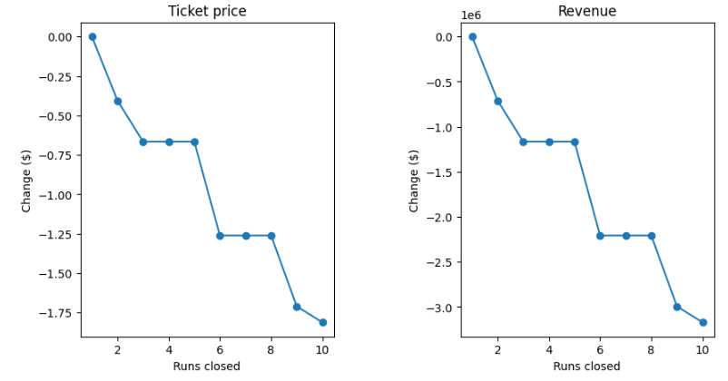

We also found that adding a lower run that would increase the vertical drop by 150 feet and a chair supported a price increase of $1.99 per ticket. We also modelled additional snow making in addition to the earlier set of features and it had no change in price.

Given the above parameters we recommend to close six of the least used runs and install a new run 150 ft lower than the bottom run increasing the vertical drop of the resort and installing the chair to service it. That would net a decrease in five runs which should lower the ticket price by approximately 0.70 per ticket but the vertical drop extension with chair lift would increase the ticket price by 1.99 for a net increase of 1.29 per ticket or approximately 2.25M in an annual revenue increase. I would not invest in extra snow making as that did not make a difference. The additional revenue would support the cost of the additional chair lift of $1.54M.

In summary, the random forest model provided Big Mountain with a baseline modelled conservative price and some insights as to which highly correlated features would significantly impact ticket prices. In the end assessment we found that Big Mountain’s current price was well supported by the data which meant that only small adjustments should be made that were in alignment with modelled feature price changes.